REHOBOAM v2: A High-Frequency Pairs Trading Expert Advisor for MetaTrader 5

Njoroge, S.N.

EMAIL: njorogenjai11@gmail.com, TEL: +254798 937 840

2025

# Abstract

Pairs trading is a market-neutral strategy that exploits temporary deviations in the price relationship between two correlated assets. This paper presents a detailed analysis of REHOBOAM v2, an Expert Advisor (EA) implemented in MQL5 for the MetaTrader 5 platform. The EA employs a statistical arbitrage approach using correlation as a proxy for cointegration, calculating a hedge ratio to form a synthetic spread between user-specified symbol pairs. It operates in a high-frequency trading (HFT) mode, executing decisions on every tick while incorporating risk management through position sizing, stop-loss, and take-profit mechanisms. We derive the mathematical foundations of the strategy, including hedge ratio computation, Z-score normalization, and risk-based lot sizing. The enhancements in v2 over its predecessor are highlighted, emphasizing improved responsiveness and flexibility in exit conditions.

***Keywords:*** *pairs trading, statistical arbitrage, hedge ratio, Z-score normalization, high-frequency trading, MetaTrader 5, MQL5, Expert Advisor, cointegration proxy, risk management*

# INTRODUCTION

Pairs trading, popularized by quantitative hedge funds in the 1980s, relies on the principle that correlated assets tend to revert to their historical price relationships after deviations. This strategy is particularly effective in volatile markets where traditional directional trades carry higher risks. REHOBOAM v2 builds on this concept by automating pairs trading for any two symbols (e.g., GBPUSD and EURUSD) on the MetaTrader 5 platform.

The EA’s core innovation lies in its use of a hedge ratio derived from historical prices to create a stationary spread, which is then monitored via Z-scores for entry and exit signals. Unlike v1, which operated on new bar formations, v2 runs on every tick for HFT compatibility, incorporates bid/ask prices for precise spread calculations, and introduces optional Z-score-based take profits. This paper elucidates the algorithmic workflow, supported by mathematical formulations, to provide a comprehensive understanding of its mechanics.

# BACKGROUND AND RELATED WORK

Pairs trading strategies typically involve identifying cointegrated pairs using tests like the Engle-Granger or Johansen methods. However, REHOBOAM v2 simplifies this by using Pearson correlation as a proxy, which is computationally efficient for real-time trading. This approach aligns with works such as Gatev et al. (2006), who demonstrated the profitability of distance-based pairs trading on equities.

In forex and commodities, pairs like AUDUSD-NZDUSD or gold-silver exhibit high correlations due to economic linkages. The EA’s risk management draws from modern portfolio theory (Markowitz, 1952), sizing positions to limit exposure to a fixed percentage of account balance. Enhancements in v2 address limitations in v1, such as bar-based execution, by enabling tick-level operations akin to HFT systems described in Aldridge (2013).

# METHODOLOGY

## Symbol Selection and Initialization

Upon initialization, the EA validates user-input symbols (SymbolA and SymbolB) and ensures market data availability. It calculates the hedge ratio  using a lookback period of 252 bars (approximately one trading year on daily timeframes). Correlation is computed on daily returns to filter unsuitable pairs if below a minimum threshold (default 0.2 in v2, reduced from 0.8 in v1 for broader applicability).

## Hedge Ratio and Correlation Calculation

The hedge ratio  is derived from ordinary least squares (OLS) regression, treating SymbolA prices as the dependent variable and SymbolB as the independent:



where  and  are arrays of closing prices over the regression period.

Correlation  serves as a cointegration proxy, calculated on returns:





If  and not bypassed, initialization fails.

## Spread Formation and Z-Score Normalization

The synthetic spread  is formed as:



Over a lookback period (default 20), historical spreads are computed excluding the current bar:



The Z-score normalizes the current spread:



In v2’s HFT mode,  uses bid/ask prices for precision:

* **Long spread:** 
* **Short spread:** 
* **Average:** 

This accounts for transaction costs implicitly.

## Entry Conditions

Trades are entered when  (default 2.0), signaling deviation:

* If : Long the spread (buy SymbolA, sell SymbolB).
* If : Short the spread (sell SymbolA, buy SymbolB).

Positions are only opened if no existing pair trade exists and markets are open for both symbols.

## Position Sizing

Lots for SymbolA () are sized to risk a fixed percentage (default 1%) of balance, assuming an adverse move of  (from entry to stop):



where  is account balance.

The dollar risk per unit is based on tick value:



 is normalized to broker lot steps and capped by min/max lots (with a user-defined MaxLots in v2). Lots for SymbolB: , similarly normalized.

## Exit Conditions

Exits occur based on stop-loss (SL) and take-profit (TP) types.

### Z-Score Based (SL_Type = SL_ZScore)

For long spread (entry ):

* SL: 
* TP (TP_Type = TP_Multiple): 
* TP (TP_Type = TP_ZScore):  (e.g., 0 for mean reversion)

Symmetric for short spread. This assumes mean reversion within a Z-score band.

### Percentage Based (SL_Type = SL_Percent)

Monitors pair profit :

* SL: 
* TP: 

where  is equity at entry.

## High-Frequency Enhancements in v2

Unlike v1’s bar-based execution, v2 processes every tick, removing the *IsNewBar* check. This enables faster responses to market movements. Additionally, a market open check prevents trades during closures:



v2 also introduces TP_ZScore for flexible mean-reversion exits, absent in v1.

## REHOBOAM v2 MetaTrader Tests

To evaluate REHOBOAM v2, we conducted backtests on historical data from MetaTrader 5 (2024 - 2025) using one forex pairs: GBPUSD-EURUSD, chosen for its high liquidity. Optimization test and backtesting was done for the period from September 1st 2025 to September 5th 2025. Two tests were done to gauge the best take profit method. The optimization criterion that was being optimized was the Sharpe ratio with the combination that gave the maximum Sharpe ratio being favored

* Take Profit (TP) based on multiple of stop loss
* Take Profit (TP) based on Z-score

The following were the settings used:

Table : tester settings

|  |  |
| --- | --- |
| Setting | Value |
| EXPERT | REHOBOAM v2 |
| SYMBOL | GBPUSD |
| PERIOD | M1 |
| OPTIMIZATION | 0 = Show complete algorithm |
| MODEL | 4 = Every tick based on real ticks |
| FROM | September 1st 2025 |
| TO | September 5th 2025 |
| FORWARD MODE | 0 = NO |
| DEPOSIT | 15000 |
| CURERNCY | USD |
| PROFIT IN PIPS | 0 = NO |
| LEVERAGE | 100 |
| EXECUTION MODE | 221 |
| OPTIMIZATION CRITERION | 5 = SHARPE RATIO MAX |

Table : tester input settings - TP as multiple of stop loss

|  |  |
| --- | --- |
| Setting | Value |
| SymbolA | GBPUSD |
| SymbolB | EURUSD |
| TIMEFRAME | 1 |
| LOOKBACK PERIOD | 20 |
| REGRESSION PERIOD | 252 |
| EntryZScore | {start: 0, stop: 10, step: 0.2} |
| StopZscore | {start: 0.2, stop: 10, step: 0.2} |
| TakeProfit Zscore | *Does not apply* |
| RiskPercent | 1 |
| MinCorrelation | 0.2 |
| BypassCorrelationCheck | false |
| Magic Number | 12345 |
| RiskRewardRatio | 2 |
| SL_Type | 0 = Z-Score based stop loss |
| TY_Type | 0 = TP as multiple of stop loss |
| StopLosspercent | *Does not apply* |
| MaxLots | 5 |

Table : tester input settings - TP based on Zscore

|  |  |
| --- | --- |
| Setting | Value |
| SymbolA | GBPUSD |
| SymbolB | EURUSD |
| TIMEFRAME | 1 |
| LOOKBACK PERIOD | 20 |
| REGRESSION PERIOD | 252 |
| EntryZScore | {start: 0, stop: 10, step: 0.2} |
| StopZscore | {start: 0, stop: 10, step: 0.2} |
| TakeProfit Zscore | {start: 0, stop: 10, step: 0.2} |
| RiskPercent | 1 |
| MinCorrelation | 0.2 |
| BypassCorrelationCheck | false |
| Magic Number | 12345 |
| RiskRewardRatio | 2 |
| SL_Type | 0 = Z-Score based stop loss |
| TY_Type | 1 = TP based on Z-Score |
| StopLosspercent | *Does not apply* |
| MaxLots | 5 |

The following is the price history of GBPUSD and EURUSD during the test periods

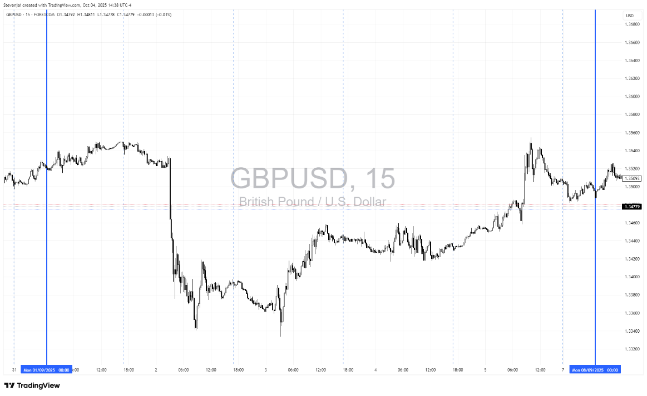

Figure : GBPUSD- 15m chart - september 1st to 5th

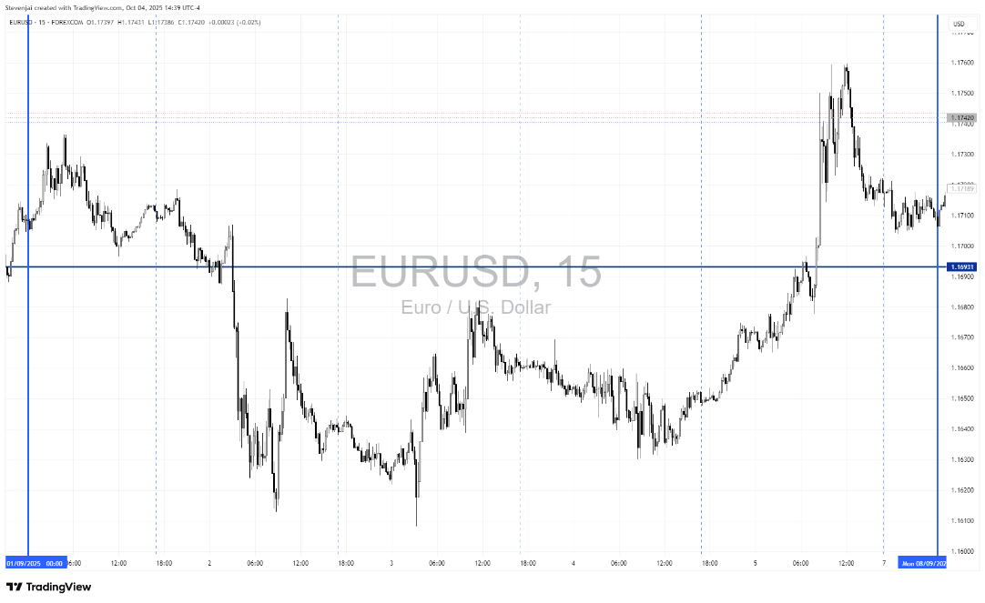

Figure : EURUSD 15m chart- September 1st to 5th

# RESULTS

## TP as multiple of stop loss

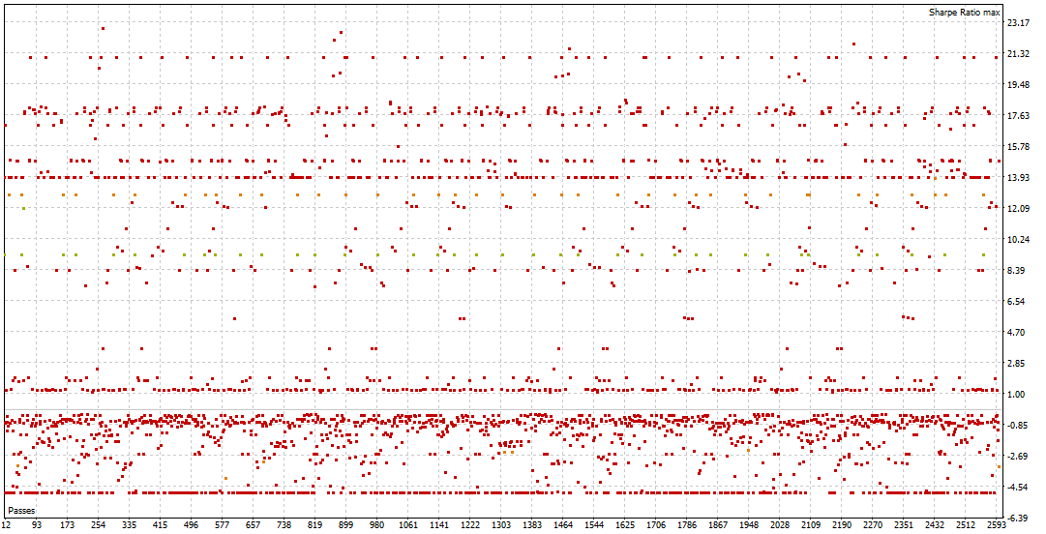

Figure : passes vs Sharpe ratio

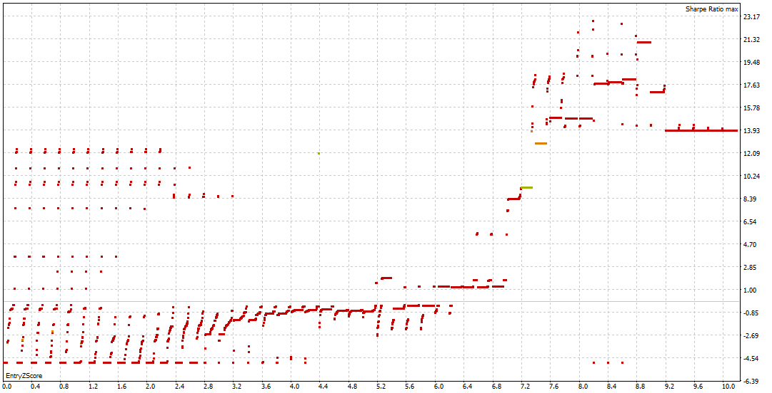

Figure : EntryZscore vs Sharpe ratio

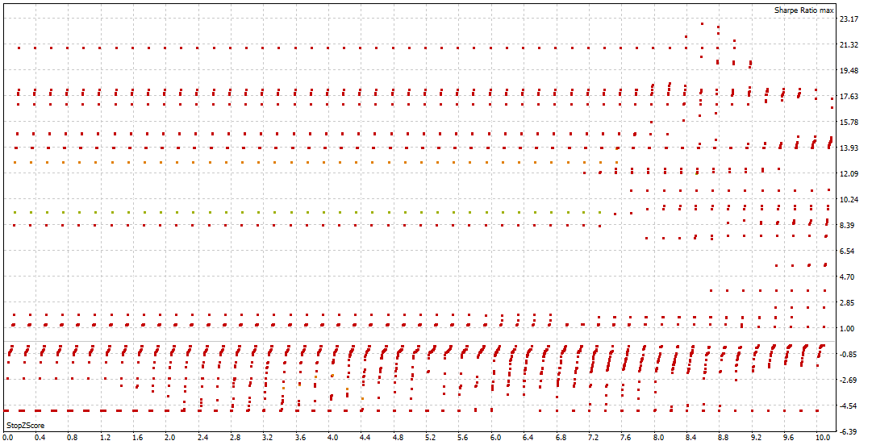

Figure : Stop Zscore vs Sharpe ratio

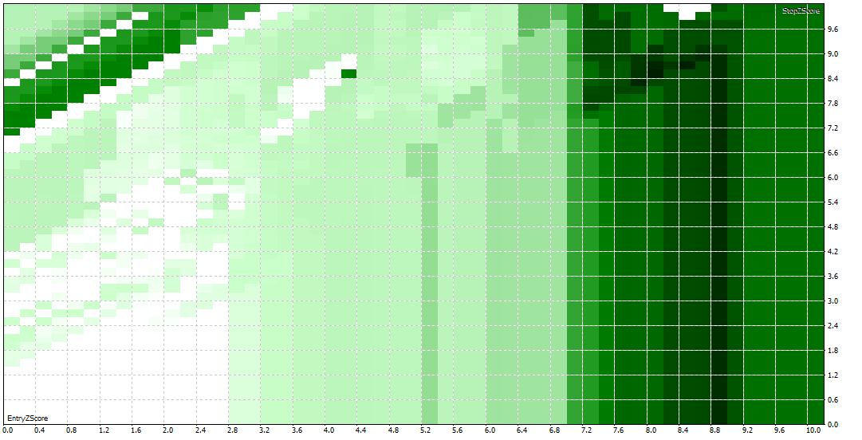

Figure 4: Entry Zscore vs Stop Zscore

The darker the green, the higher the Sharpe ratio.

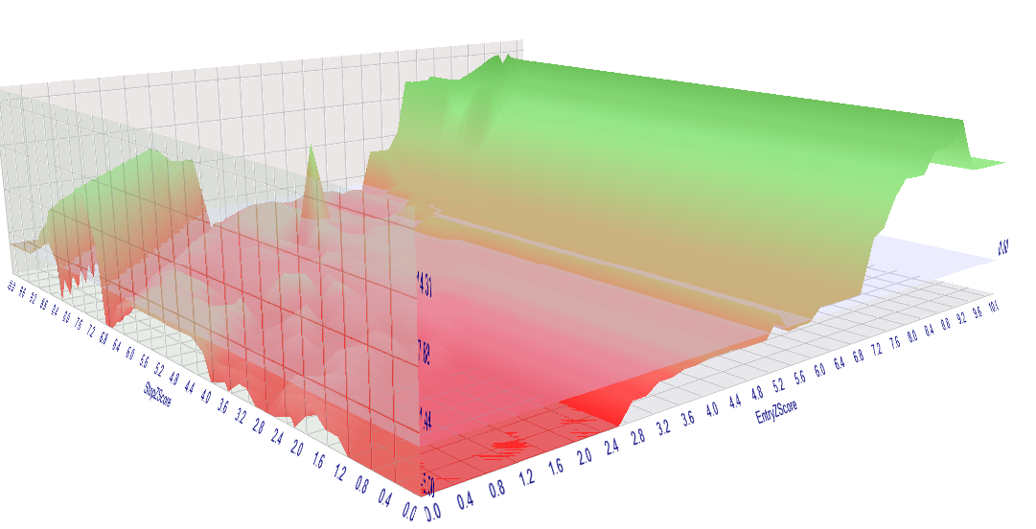

Figure 5: 3D graph of stop Zscore vs Entry ZScore vs Sharpe ratio (on the Z axis)

## TP based on Zscore

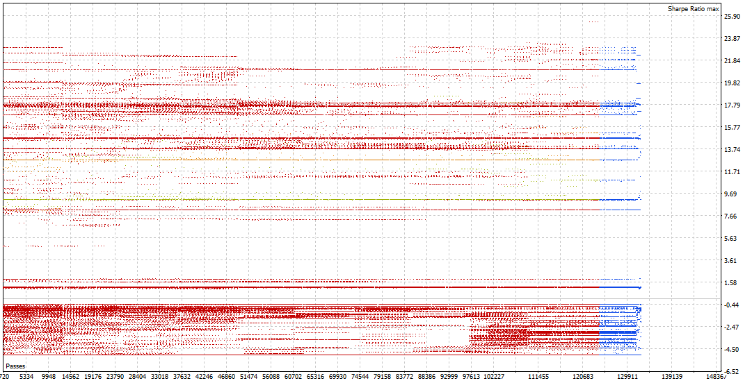

Figure 6: passes vs Sharpe ratio

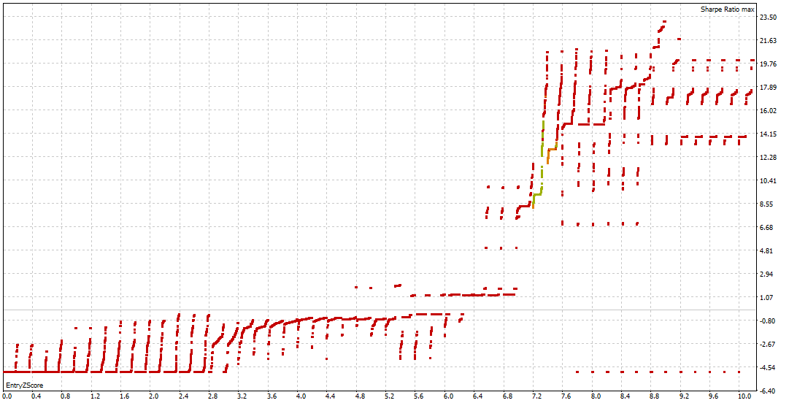

Figure 7: Entry Zscore vs Sharpe ratio

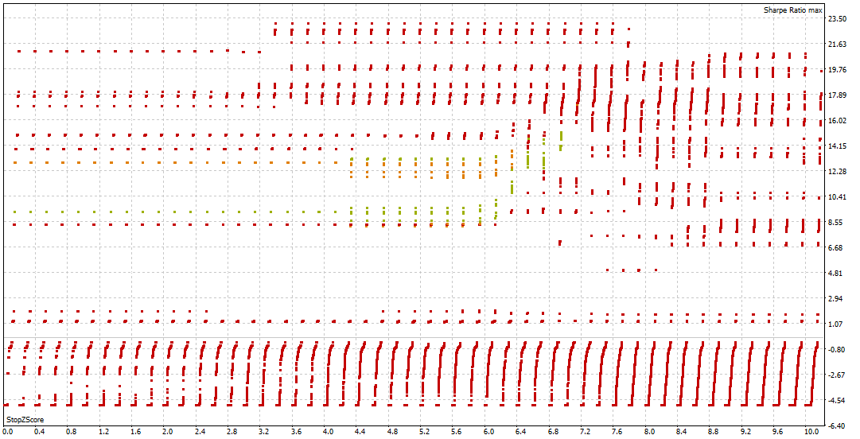

Figure 8: stop Zscore vs Sharpe ratio

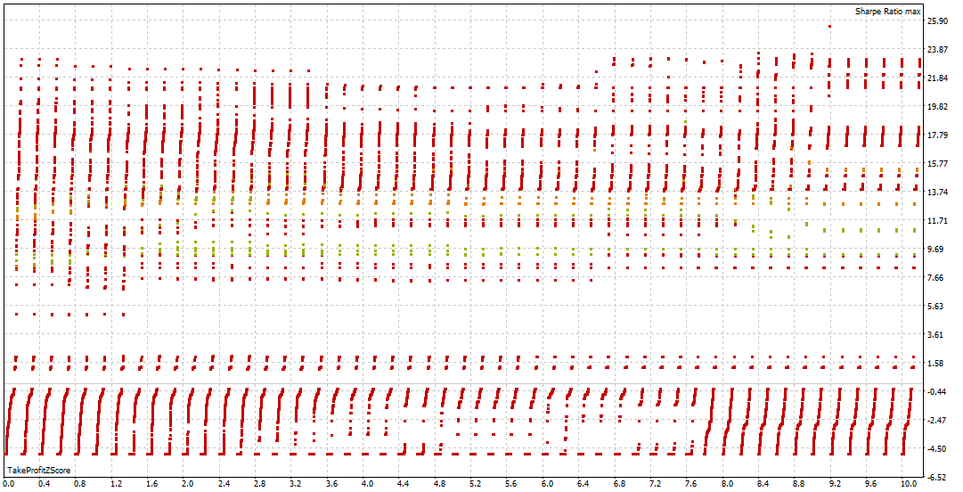

Figure 9: takeProfit Zscore vs Sharpe ratio

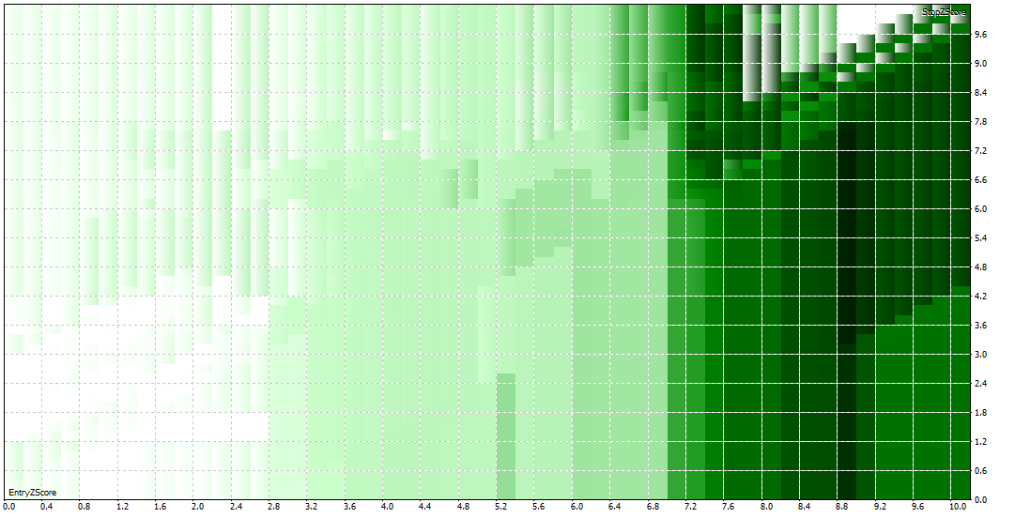

Figure 10: Entry Zscore vs Stop Zscore

The deeper the color, the higher the Sharpe ratio

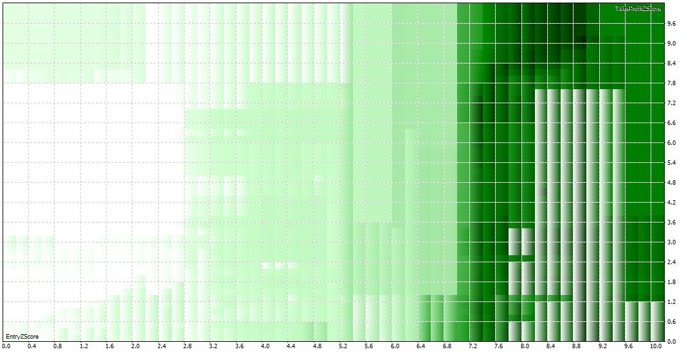

Figure 11: Entry Zscore vs take Profit Zscore

The deeper the color, the higher the Sharpe ratio

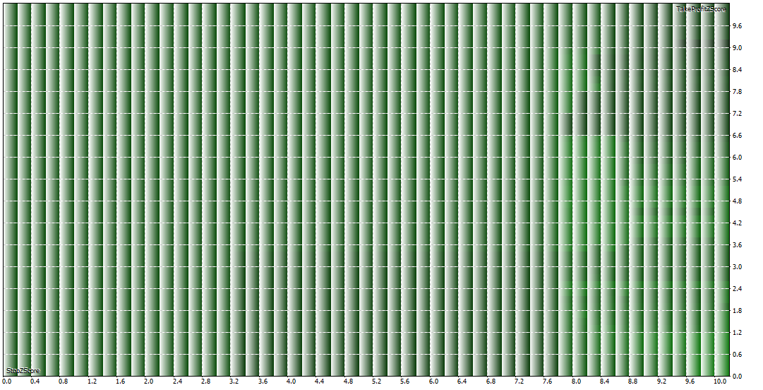

Figure 12: take Profit Zscore vs Stop Zscore

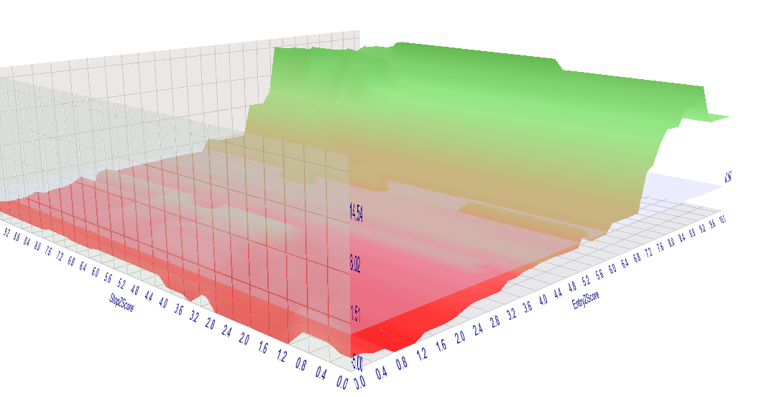

Figure 13: Stop Zscore vs Entry Zscore vs Sharpe ratio (on z axis)

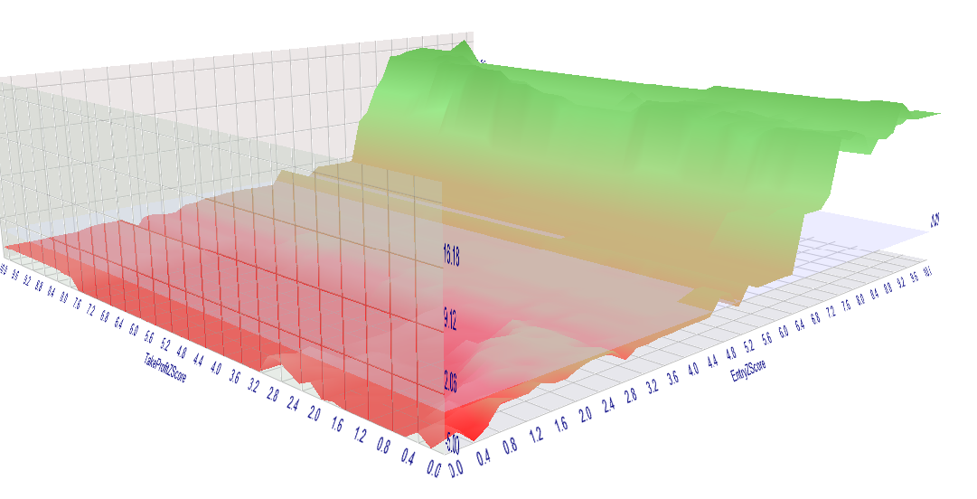

Figure 14: take Profit Zscore vs Entry Zscore vs Sharpe ratio (on the Z axis)

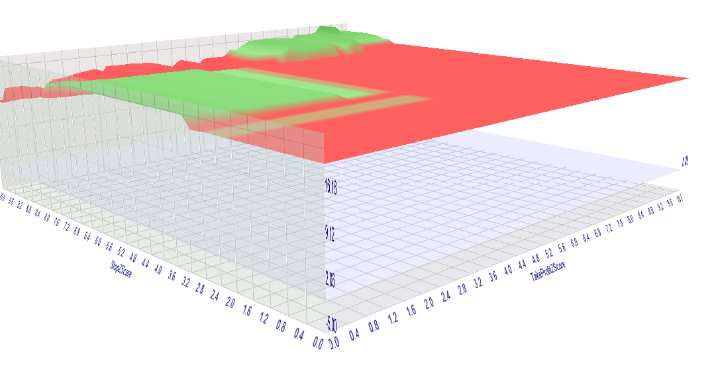

Figure : Stop Zscore vs Take profit Zscore vs sharpe ratio

# DISCUSSION

## Analysis

## Discussion

# MATHEMATICAL VALIDATION AND ASSUMPTIONS

The strategy assumes the spread is stationary, validated indirectly via correlation. Under normality, Z-scores follow a standard normal distribution, with thresholds corresponding to confidence levels (e.g., 2  95%). Position sizing assumes the adverse move is linearly related to , which holds under Gaussian assumptions but may fail in fat-tailed markets.

Potential limitations include slippage in HFT mode and correlation breakdown during regime shifts. Future extensions could incorporate formal cointegration tests or adaptive lookbacks.

# RECOMMENDATIONS

# CONCLUSION

REHOBOAM v2 represents an advanced, user-configurable pairs trading EA optimized for high-frequency execution. By leveraging hedge ratios, Z-score signals, and risk-controlled sizing, it provides a robust framework for statistical arbitrage. The mathematical formulations outlined ensure transparency and reproducibility, making it suitable for both educational and practical applications in algorithmic trading.

# *References*

1. Aldridge, I. (2013). *High-Frequency Trading: A Practical Guide to Algorithmic Strategies and Trading Systems*. Wiley.
2. Gatev, E., Goetzmann, W. N., & Rouwenhorst, K. G. (2006). Pairs Trading: Performance of a Relative-Value Arbitrage Rule. *Review of Financial Studies*, 19(3), 797–827.
3. Markowitz, H. M. (1952). Portfolio Selection. *Journal of Finance*, 7(1), 77–91.

# APPENDIX

## Rehoboam v2.ini

[Tester]

Expert=REHOBOAM-v2.ex5

Symbol=GBPUSD

Period=M1

Optimization=0

Model=4

FromDate=2025.09.01

ToDate=2025.09.30

ForwardMode=0

Deposit=15000

Currency=USD

ProfitInPips=0

Leverage=100

ExecutionMode=221

OptimizationCriterion=5

Visual=0

[TesterInputs]

SymbolA=GBPUSD

SymbolB=EURUSD

Timeframe=1||0||0||49153||N

LookbackPeriod=20||20||1||200||N

RegressionPeriod=252||252||1||2520||N

EntryZScore=1.2||0||0.1||10||Y

StopZScore=5||0||0.5||10||Y

TakeProfitZScore=5||0.0||0.5||10||N

RiskPercent=1.0||1.0||0.100000||10.000000||N

MinCorrelation=0.2||0.2||0.020000||2.000000||N

BypassCorrelationCheck=false||false||0||true||N

MagicNumber=12345||12345||1||123450||N

RiskRewardRatio=2.0||2.0||0.200000||20.000000||N

SL_Type=0||0||0||1||N

TP_Type=1||0||0||1||N

StopLossPercent=2.5||2.5||0.250000||25.000000||N

MaxLots=5.0||5.0||0.500000||50.000000||N

## Rehoboam-v2.set

; saved on 2025.10.04 17:12:53

; this file contains input parameters for testing/optimizing REHOBOAM-v2 expert advisor

; to use it in the strategy tester, click Load in the context menu of the Inputs tab

;

SymbolA=GBPUSD

SymbolB=EURUSD

Timeframe=1||0||0||49153||N

LookbackPeriod=20||20||1||200||N

RegressionPeriod=252||252||1||2520||N

EntryZScore=1.2||0||0.1||10||Y

StopZScore=5||0||0.5||10||N

TakeProfitZScore=5||0.0||0.5||10||N

RiskPercent=1.0||1.0||0.100000||10.000000||N

MinCorrelation=0.2||0.2||0.020000||2.000000||N

BypassCorrelationCheck=false||false||0||true||N

MagicNumber=12345||12345||1||123450||N

RiskRewardRatio=2.0||2.0||0.200000||20.000000||N

SL_Type=0||0||0||1||N

TP_Type=1||0||0||1||Y

StopLossPercent=2.5||2.5||0.250000||25.000000||N

MaxLots=5.0||5.0||0.500000||50.000000||N